Global Temperature and Atmospheric CO2 over Geologic Time
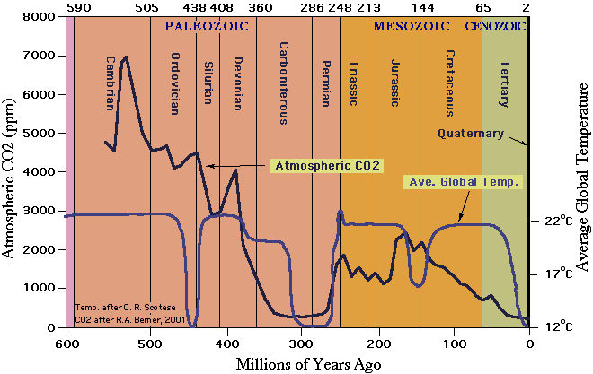

http://www.iberica2000.org/Documents/Eolica/GLOBAL_WARMING/CLIMATE_CHANGE_LATEST/TEMPERATURE_and_C02_past_700_million_years.doc

The above graph reveals two inconvenient truths :

1) - There was far more CO2 in the atmosphere in the past, for instance 1,000 to 2,000 ppm in the dinosaur era (65 - 230 million years ago). And we know that vegetation was more luxuriant then than it is now.
When the first corals appeared in the oceans 550 million years ago, CO2 levels were up to 5,000 to 7,000 ppm.

And Wikipedia confirms that, in modern times, the atmosphere of the earth is poor in CO2 : "Plants require carbon dioxide to conduct photosynthesis, and greenhouses may enrich their atmospheres with additional CO2 to boost plant growth, since its low present-day atmosphere concentration is just above the "suffocation" level for green plants." http://en.wikipedia.org/wiki/Carbon_dioxide

Yes, you read correctly : "its low present-day atmosphere concentration is just above the "suffocation" level for green plants." and … "greenhouses may enrich their atmospheres with additional CO2 to boost plant growth".

It is a fact that more CO2 in the atmosphere would benefit agricultural production, permitting to feed the additional billions of people that the earth will have to sustain in the XXIst century. It would also help green deserts, like the Sahara :
http://www.co2science.org/subject/d/summaries/desertsalgae.php

2) - The second conclusion we may draw from the graph is that there is no correlation between temperature and CO2 levels. We already knew that from the fact that average global temperature went down from 1945 to 1975, when CO2 levels were increasing. We also know that it went down again in the past 10 years, in spite of sharply increased CO2 emissions resulting from the emergence of new industrial giants : India and China.

But if temperature went down in the past 10 years, how come the data we are being provided by NASA seems to tell us the opposite ?
- Because some statistics and charts are being manipulated, in an effort to scare populations for political purposes :
www.iberica2000.org/Es/Articulo.asp?Id=3814

Why scare people ? - Well, basically it permits to increase taxes ( carbon taxes, or carbon “cap and trade” ) thus helping governments with their budget deficits. It permits to return to protectionism ( carbon tariffs ), which would help western industry to survive competition from China and India ( but ruin our economies in the long run through inflation and reduced competitiveness ). It allows governments to spend lavishly on unnecessary things such as wind turbines, bio fuels, and other boondoggles that benefit vested interests and corrupt politicians. It also helps governments violate planning and environmental laws, such as allowing wind farms to be built in natural reserves.

Most of all it generates a large flow of money from taxpayers (carbon taxes) to the following beneficiaries :
- the windpower and other “renewable industries”
- climate scientists
- ornithologists
- bird societies
- ecologists
- newly created civil servant jobs
- corrupt politicians
- “global warming businesses” ( carbon traders, consultants, )
- crooks abusing the carbon offset and other such schemes

The green-industrial complex gets rich from carbon laws :

http://www.theaustralian.news.com.au/story/0,25197,25724257-7583,00.html

It is also used as a justification for flying 10,000 people to expensive conferences in Kyoto, Rio de Janeiro, Poznan, Copenhagen etc.

Is CO2 a pollutant ?
- Not in the least ! Sulphur dioxide and nitrogen dioxide are pollutants, but not CO2.
CO2 is the wrong devil. Without CO2 there would be no plants on earth, and no life.
As for carbon, it is one of the building blocks of life. Animals ( and humans ) are made of carbon and other atoms.
CO2 should not be confused with CO ( carbon monoxide ), which is a deadly gas.
This confuses many people, and manipulators of public opinion take advantage of that to scare them with CO2.

Mark Duchamp + 34 693 643 736
Director, Climate Change and Alternative Energies
Iberica 2000
Partida La Sella, 25
03750 Pedreguer, Spain
www.iberica2000.org

