http://blogs.news.com.au/heraldsun/andrewbolt/index.php/heraldsun/comments/going_cold_on_antarctic_warming#48360

Going cold on Antarctic warming

Andrew Bolt
Wednesday, February 04, 2009 at 12:04am

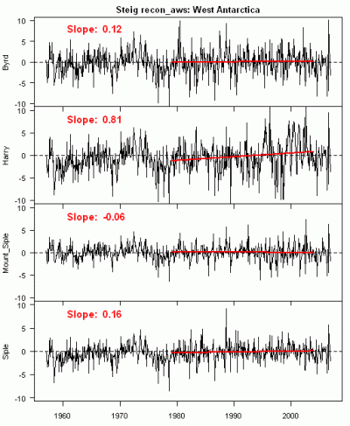
Professor Eric Steig last month announced in Nature that he’d spotted a warming in West Antarctica that previous researchers had missed through slackness - a warming so strong that it more than made up for the cooling in East Antarctica.
Whew! Finally we had proof that Antarctica as a whole was warming, and not cooling, after all. Global warming really was global now.
The paper was immediately greeted with suspicion, not least because one of the authors was Michael Mann of the infamous “hockey stick”, now discredited, and the data was reconstructed from very sketchy weather station records, combined with assumptions from satellite observations.
But Steve McIntyre, who did most to expose Mann’s “hockey stick”, now notices a far more embarrassing problem with Steig’s paper.
Previous researchers hadn’t overlooked the data. What they’d done was to ignore data from four West Antarctic automatic weather stations in particular that didn’t meet their quality control. As you can see above, one shows no warming, two show insignificant warming and fourth - from a station dubbed “Harry” shows a sharp jump in temperature that helped Steig and his team discover their warming Antarctic.
Uh oh.
Harry in fact is a problematic site that was buried in snow for years and then re-sited in 2005. But, worse, the data that Steig used in his modelling which he claimed came from Harry was actually old data from another station on the Ross Ice Shelf known as Gill with new data from Harry added to it, producing the abrupt warming. The data is worthless. Or as McIntyre puts it:
Considered by itself, Gill has a slightly negative trend from 1987 to 2002. The big trend in “New Harry” arises entirely from the impact of splicing the two data sets together. It’s a mess.
Read this link and this to see McIntyre’s superb forensic work.
Why wasn’t this error picked up earlier? Perhaps because the researchers got the results they’d hoped for, and no alarm bell went off that made them check. Now, wait for the papers to report the error with the zeal with which they reported Steig’s “warming”.

